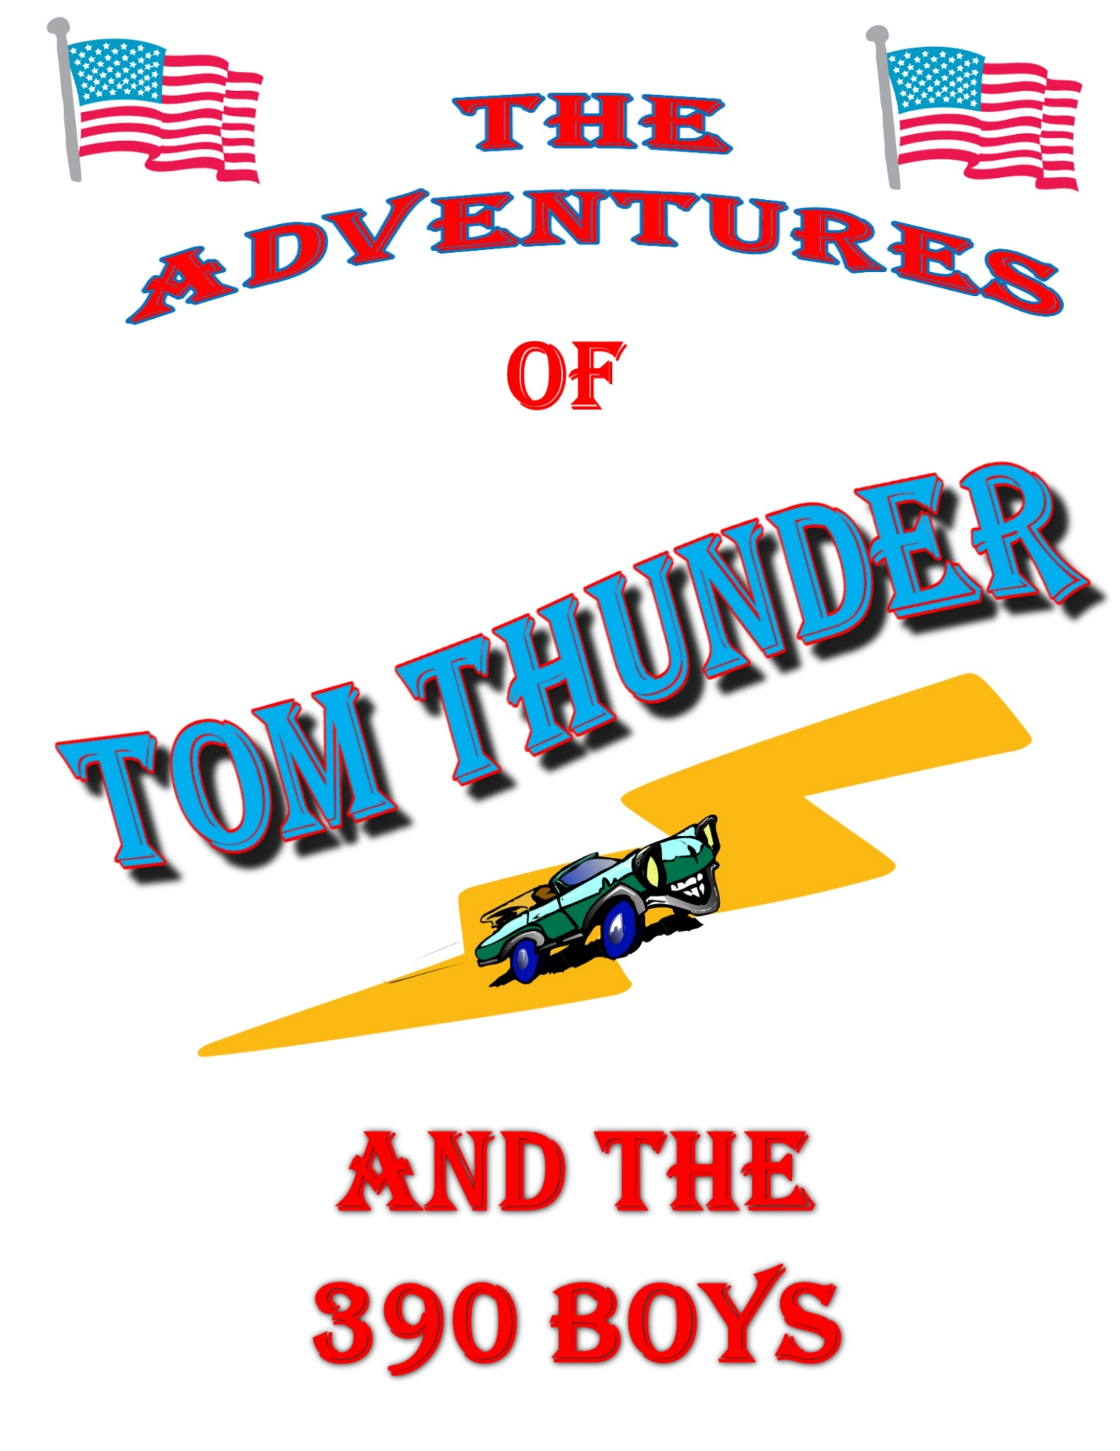

DISCLAIMER

Note to the reader from the Author

This short story (quick little yarn really) is intended to be taken with a grain of salt and enjoyed for what it is – no more and no less. At times it may be cornball and maybe a bit rude, but never crude. It is in keeping with the old adventure serial dime store novels of yesteryear. If you are too young to know or understand what that means, then hopefully you are in for a treat. If at times you find this “politically incorrect”, or laden with “micro aggressions”, then good you have come to the right place for your cure.
However, you can rest assured that this is all organic 100% gluten free, and absolutely no animals were harmed during the writing of this magnificent manuscript. Global warming was not impacted or a factor in its development. The sun still rose in the East and set in the West, before, during, and after every Chapter.
Tom Thunder is a free spirit and loyal Freedom Loving American and says things as he sees it. He enjoys the freedoms this great nation offers its citizens to succeed. He won’t lie, cheat or steal from you. He will back your play if he feels you are in the right. But, if he thinks you are in the wrong he won’t hesitate to tell you so, and if necessary go toe to toe with you.
Some of what you are about to read actually happened and is 100% true. This would be discoverable under oath during cross examination in a court of law. The rest of it is full on embellishment. Which is a legal definition derived from the Latin term Bulllistshitcus.
Remember this is all in fun and all the characters are fictitious. Even if you think they are you, they are not!!!
“Keep Hopping Fences and Stay One Step Ahead Of The Yard Dogs”
Tom Thunder
Cast of Characters

- Tom Thunder – Man of action and American patriot
- Birdie – Thunders gal pal and business partner
- Ley Roy – Up and coming future man of action
- Lightning – Wonder dog and loyal sidekick
- The 390 Boys:
  - Elmer – Base Guitar, Harmonica & Vocals
  - Sax – Saxophone and Keyboards
  - Rocket – Drums & Vocal Backup Harmony
  - Thunder – Lead Guitar, Singer and Song Writer
- Will Power – (AKA No Will Power) Owner of “The Power Bar”
- Sargent Jimmy Beanso – Sac Town PD
- Detective 1st Grade Mooch – Local PD
- Buds – Just a Punk

*Introducing the Keyhole Gang

Prelude

Tom Thunder is contacted, out of the blue, by an old High School buddy. He is desperate and asks for Thunders help. Thunder agrees to help his old friend out of the jam he is in. But, he will need to go undercover to infiltrate deep into the lair of the group of crooks that have infested the business operations of the “Power Bar”.
Thunder will have to put his old band back together in order to create the necessary cover for this operation. He calls upon his old running partners. The one and only 390 Boy’s.
However, there is more here than meets the eye as Thunder begins to unravel the Rats Nest of crime.
These crooks have no idea of the magnitude of the Thunder and Lightning storm that is about to befall them.
Let’s now join our hero as he once again foils those who choose to harm Americans and the American way of life.

CHAPTER 1 - Keep Hopping Those Fences

CHAPTER 2 - You Want Some Fries With Those Troubles

CHAPTER 3 - The 390 Boys

CHAPTER 4 - Up In Smoke – Puff The Magic (Bus) Dragon

CHAPTER 5 - Build A Better Rat Trap

CHAPTER 6 - Nice Hat

CHAPTER 7 - Opening Night

CHAPTER 8 - Out Of The Car Long Hair

CHAPTER 9 - What A Scam

CHAPTER 10 - Is It Real Or Memorex

CHAPTER 11 - Broke Down And Busted
- (SIX MONTHS LATER & PHOTO SHOOT)

The Case Of
“This Buds For You”

CHAPTER 1 – KEEP HOPPING THOSE FENCES
Thunder rolled out of the rack to the sound of Lightning barking out of the window that overlooks the rear yard. Thunder’s eyes began to focus as he looked out from his second story vantage point.
There on the back fence were four kids standing on the top rail. They looked like a bunch of tightrope acrobats and were attempting to walk the length of the fence over to the other side. They all had their arms stretched out to help them balance and they were slowly inching their way along.
Thunder was smiling because he and the guys he grew up with did the same thing. He thought it was cool that the tradition of fence hopping lived on.
Thunder didn’t really care that they were ‘walking the rails’ as they used to call it. But, just for the fun of it he played the part of the mean old man.
Thunder said in a loud voice: “Hey you kids, get off that fence!”
They all looked up at the same time, their faces showing fear and panic. All except for one kid, his expression was more of defiance than fear.
As they began to tumble off the fence like a line of dominoes, Thunder thought he could hear the defiant kid say: “Stupid Ass Gezer!”.
They all fell over and safely landed on the alley side of the fence. All except for the one kid who was quick to give his opinion of the person disrupting their concentration and who foiled their attempt to cross. He landed squarely in Thunders yard and flat on his keester. He looked a little surprised just sitting there and was analyzing his predicament.
Thunder stood at the window laughing and said: “Hey kid. You alright?”
The kid just sat there and stared up at Thunder. Then he delivered a snappy one finger salute. Thunder laughed a little harder now and was thinking this kid has got guts. It was rude and defiant but he showed spunk, and Thunder liked that.
Thunder: “Hey kid nice try. But, if I were you, I wouldn’t hang around. Lightning is on his way down there to greet you right now.”
Just then Lightning burst into the yard from the side door of the shop. The kid took one look at Lightning, jumped up, and sprinted for the fence. You could hear his buddies in the background yelling for him to hurry up. Lightning was on a full run and barking the whole way. As Sherlock Holms would say ‘The game is afoot’.
Thing is, Lightning would not have hurt the kid in anyway shape or form. To him it was all just a big game of ‘Chase um and Round um up’, it was his herding instinct. But, the kid didn’t know that, and that’s just the way Thunder wanted to keep it.
Thunder watched as this agile youth hit the fence on a full run. He leapt up so his hands grabbed the top of the fence and in one pull he was up, and flipping his entire body over the top rail. He landed safely on the other side to join his buddies. Thunder thought nicely done kid.
Thunder said to himself out loud: “Kid has skills”.
Lightning gave up the chase and sort of pranced and trotted back to the shop. He was all proud because he once again cleared his yard of unwelcome intruders. The Boss Dog (AKA Thunder) ought to be pleased with that. Should earn him an extra cookie or something.
With all the excitement and commotion over with Thunder went to the sink and threw some water on his face. He could smell the aroma of fresh brewed coffee wafting up from down stairs. That meant Birdie was in the office and getting things started for another busy day at ‘Thunder City Garage’.
Thunder finished getting dressed and headed downstairs. There he saw Birdie reaching up to get down a roll of paper towels from the overhead cabinet. As she did her fitted skirt lifted up just enough to show off her gorgeous legs and just a hint of her shapely bottom. Thunders heart skipped a beat and he thought just how much excitement can one guy take in one morning.
But, being the gentleman that he was, all he said was: “Morning Birdie”.
Birdie: “Morning Thunder, and by the way, stop looking at my butt!”
Thunder thought that’s amazing, her backs turned and yet I still got busted.
Thunder: “Can’t help it babe, after all I am a dude. It just comes natural.”
Birdie: “I’ll take that as a compliment. Now, you want some coffee? It’s fresh.”
Thunder: ”Sounds great”
As Thunder sat down at his desk and sipped his cup of Joe, Birdie informed him that a group of young tuffs ran out from the back alley as she drove up this morning. He might want to check around to see if anything was stolen.
“Sure will babe”. Is all that Thunder said, as he smiled shaking his head.
After going over a billing invoice for the last restore job they finished the week before, and making sure he had all the time and materials accounted for, he handed it to Birdie.
“That one’s ready to go out babe. I’ll be in the shop if you need me.”
He headed into the shop and over to where their new project was parked. It was 1964 Pontiac GTO, or to those in the know a Gran Turismo Omologato. Talk about bells and whistles this beauty had that and a full marching band to go with it. Another testament to an all American made engineered masterpiece of rolling power and muscle.
It was a two door hardtop sedan equipped with the full package. It had a 389 V8 that delivered 325 horsepower stock, but with the additional Bobcat tune kit it boosted it another 50 horses. It came right out of the factory with a four speed manual Hurst shifter (Four On The Floor). You could hit the race track right off of the showroom floor and have the whole thing covered under warrantee.
Thunder went over to the shop radio and turned it on. He liked real music played with real instruments and lyrics, so it was set for the ‘Oldies Station’. Hip Hop and Rap Crap showed zero talent in his opinion. Hell, he would even take DISCO over that wasteland! At least DISCO wasn’t all negative, cop hating, woman degrading, racist dribble.

The DJ was announcing the next song.
“Hey Cats What’s the Haps – You can spin your wheels and I will spin some wax! Check this one out by Ronnie and the Daytonas.”
“Little GTO – Your Really looking Fine – Three Deuces and a Four Speed – And A Three Eighty Nine - … AH WAA WAA and AH WAA WAA WAA…”
Wow, now if that ain’t a ‘co wink a dink’, thought Thunder.
Just then Birdie’s voice came over the overhead squawk box.
“Thunder pick up the phone”, was the announcement.
He looked over at the shop wall phone it was line one blinking. He thought that’s good I don’t really need any more international intrigue right now. He turned down the music and lifted the receiver.
“Thunder City Garage – this is Thunder”
The voice on the other end said: “Tom Thunder is that you man?”
“Last I checked – But just call me Thunder. Who’s this?”
“William Power, you know Will, from High School – Remember me?”
“Ya, I remember you. We used to call you “No Will Power”
“Yup – you got it man”
Thunder: “So what can I do for you Will, after all these years? You looking to rebuild a classic?”
Thunder could tell by the tone in his voice that it wasn’t going to be that simple. But, he didn’t want to shut the guy down too fast either. He would let him state the reason for the call before he made any decisions one way or another. After all they were buds in high school. He owed him that much courtesy anyway.
Will: “How you been man? I bet I haven’t seen you since the five-year reunion. What year was that? I bet it had to be at least…..”
Thunder interrupted him in mid-sentence.
Thunder: “Hey Will, let me make it easy on you okay. You didn’t call me to get caught up on old times. So why don’t you just spit it out and let’s talk about what you really called for.”
Will: “Okay, you’re right Thunder. I am calling you because I am at my last turn. I have tried everything else I could think of but I keep coming up short, in more ways than one.
Truth is I’m losing my bar and for the life of me I can’t figure out how. I have had two private detectives looking into it and I have been combing over my financial books with a fine tooth comb and found nothing. Then I remembered you always saying, ‘If you were a friend of Tom Thunders you had a friend for life’.
So, I was hoping you could help me out. I know this sounds like small potatoes for you, but Thunder, I really need your help man. Can you help me?”
Thunder listen to his old friend and after he finished with his appeal for his help he decided to offer to meet with him for a cup of coffee. That way he could hear all of it before he gave him his decision.
Face to face meetings were always better than trying to talk over the telephone. He set a time for later in the afternoon. He would have to drive to Sac Town, and that was about an hour away. He walked over to the office and peeked in. There was Birdie sitting at her desk talking to one of the venders on the phone. She looked up at him and held up one finger indicting that the call was almost over.
She hung up the phone and looked straight at Thunder and said: “Now what?”
She had a feeling that phone call for Thunder was a little to mysterious. Something was up and she was about to find out.
Thunder: “I have to run into Sac Town for a bit to meet an old high school buddy with a problem”
Birdie: “Would that be a car problem? Because, that’s the kind of business we are in. Remember Thunder?”
Thunder: “Well, not exactly. But, hey I won’t be long, and if your good, I will bring back some of that home style handmade candy you like from Isabel Ringen’s candy shop”.
Birdie “Thanks, but no thanks. This skirt is tight enough as is without adding any candy to it”
Thunder: “Really? I hadn’t noticed.”
Thunder winked at Birdie and flashed his pearly whites at her smiling as he walked over to his 1966 Thunderbird convertible. He whistled for Lightning, who came running around the corner, and as he did, lost his footing when he hit the slick polished floor. He slid right into a stack of hubcaps. They went flying, rolling, bouncing and clanking all over the shop floor.
Thunder made the motion of a Baseball Umpire as if a runner was sliding in to home plate. Then he said: “Safe!!!”.
Lightning dropped his ears and slinked into the passenger seat.
Birdie got up to see what happened and waved at Thunder saying: “You two better get out of here before something else happens. I’ll get this.”
Thunder hit the key switch and the T-Bird came to life. The sound of the duel exhaust was mellow but deep. The 390 V8 was running smooth.
Thunder pulled out onto the street and headed for the freeway entrance to I-5. Next stop Sac Town. As he rounded the corner and just down the block from the shop he spotted the four young perpetrators. The fence walkers.
When they saw him coming they didn’t know if they should run and hide or hold their ground.
Two of the four didn’t wait to find out and beat feet out of there and jumped behind a juniper bush that was on the corner of the street. The other two stood there and Thunder was thinking, ‘now there is some double trouble’.
Thunder drove by them slowly, gave a friendly smile, waved and said: “Morning fella’s.”
He watched them in his rear view mirror as they all gathered back up after he had past them. He could tell they were confused by the encounter. They probably were expecting something a little more heated.

Thunder could tell they weren’t bad kids. They just were looking for something to do that would challenge them. All in all, it wasn’t a bad first encounter and ice breaker with the up and coming kings of the neighborhood. Could have been worse, but for now it was all good.
Thunder was thinking. Hey, we could use a little Double Trouble for some traveling tunes.
He looked over at Lightning and said: “I’m in the mood for some Stevie Ray Vaughan (SRV) and Double Trouble, buddy”.
He cranked up the volume and told Lightning to hit the tune box.
The last thing those kids saw and heard was the tail lights on the 66 Thunderbird as it laid down rubber to sounds of Stevie Ray Vaughn (SRV) playing ‘Pride and Joy’.
“Yeah I love my Baby – She’s Long And Lean – You Mess With Her You’ll See A Man Getting’ Mean ……. She’s My Pride And Joy”

CHAPTER 2 – YOU WANT SOME FRIES WITH THOSE TROUBLES
Thunder had agreed to meet up with Will at Maries Drive-In, it was off of 14th Avenue. It was a hangout spot when they were in high school. The place had some wear on it, but it was mostly the same as it was. It made a good place to meet, they didn’t have any of that stupid overhead music drowning out normal conversation. It was out of the way and quite so they could talk. They made a pretty darn good hamburger too.
When Thunder pulled into the parking lot he spotted “No Will Power” just sitting inside at one of the wooden BBQ tables. The place was empty except for him. Good, Thunder thought, no interruptions. He got out of the car and told Lightning to stay and Bird watch.
As he headed in the smell of those burgers brought back a lot of memories, some good, some not. He ordered his old favorite, a Special Deluxe Cheese Burger, fries and shake to eat there, and one plain burger with extra catsup on it to go. Lightning liked his burgers with lots of catsup.
He sat down at the table and listened to what Will Power had come to say. After about an hour and one more of Maries’ ‘Special Deluxe Cheese Burgers’, Will had laid out all his troubles.
Thunder: “Sounds like you got a problem alright. I’ll do what I can to help you out. I will have to put the band back together again for this operation. That will be our cover. I will call you back later with the details of what I am going to need from you. Is all that acceptable to you?”
Will: “Absolutely”
Thunder: “Ok that’s it for now Will. I’ll be in touch”.
Will: “Hey, before I leave I have to say that is one beautiful car man. What is it?”
Thunder: “Thanks. It’s a 1966 Thunderbird. All American built and sent here to California right off the assembly line. I call her ‘California Girl’.
Will: “From the Beach Boy’s song right, ‘I wish they all could beat California Girls’.
Thunder: “You got it.”
Thunder walked over to the car and tossed Lightning his burger, which he caught in midair, and almost swallowed in one gulp. He was smacking his lips as that extra catsup oozed out and covered his mussel.
All Thunder said was: “Don’t get any of that on the seats”.
He fired up the engine and told Lightning to hit the tune box. He pulled out of the parking lot and headed towards Highway 50 and back to Thunder City Garage.
Thunder and Lightning were heading west down Highway 50, which leads towards the heart of Sac Town. This is where they would make the interchange to South HWY 99. He thought it might be better than I-5 this time of day, less Big Rigs anyway. But, before they did Thunder decided to take a bit of a side trip and check out some of the old neighborhoods around where Will’s bar was located.
His joint was located at the Old Cannery on Stockton Boulevard. Back in the day the Cannery was a major part of the booming economy of the town and employed thousands of people over the years. Now it’s just another retro hip vibe “Metro” complex. They kept the old brick façade to give it that nostalgia look.
If he could remember right, it was on 29th or 30th somewhere around Alhambra Boulevard, not far from the Memorial Auditorium. He exited off at Stockton Boulevard and that put him practically right in front of the place. He stopped at the light and waited as the Light Rail passed by on the old train tracts.
He drove around to the front of the building and parked across the street to get a ‘Birdseye’ view. As he sat there, he watched a delivery truck being loaded and what looked like curious activity if not full on suspicious.
All Thunder said was: “Interesting”.
Having seen enough for now he turned to Lightning and said: “Hey, we need some traveling tunes buddy – Hit the tune box.”
Lightning punched the tune box with is paw and as they rounded the on ramp to HWY 99 the sounds of ‘Born To Be Wild’ by Steppenwolff was blasting from all eight speakers.
“Get your motor runnin’ ---- Head out on the highway----- lookin’ for adventure ---– And whatever comes our way----- Born To Be Wild ------“
CHAPTER 3 – THE 390 BOYS
Thunder had been putting together his plan of action on the drive back home. One thing was for sure. He had to put the band back together again for this to work.
After he worked out most of the details in his head, he turned to Lightning, who was hanging his head over the door with his tongue flapping in the wind.
Thunder said: “So what you think buddy? Should ought to work. Right?”
Lightning let out his approval of the plan with a bark. Then went back to flying his tongue like a flag on a ship’s mast in a twenty knot wind.
When Thunder got back to Thunder City Garage he went straight to the front office. Birdie was quick to inform him that those kids had been back and hanging around out front all morning. She had even caught one of them trying to sneak into the garage. He was attempting to let the air out of the tires of the GTO .
He just smiled at Birdie and then closed the door to his office. Birdie knew not to ask any questions and Thunder would not tell her any lies. She did her part and let him know. He didn’t seem to be all that concerned about it, so she just went back to working on the estimated work list for the 1964 GTO.
The first call Thunder made was to Sax. The phone rang for a bit and then he heard “Corn Doggie Dinner”.
Thunder: “Sax, it’s Thunder”.
Sax: “Hey man. How you doing?”
Thunder: “I need your horn man.”
Sax: “You mean you want to borrow it? My old Sax?”
Thunder: “Well yes and no. I need your sax with you playing it. I’m putting the band back together – short term.”
Sax: “You mean the 390 Boys? Seriously?”
Thunder: “As serious as a heart attack. I’m calling Elmer and Rocket next. I’ll set up a meeting and get back to you. “
Sax “Alright man. Let me know.”
Sax was thinking has Thunder gone nuts? They hadn’t played in years. Not since Thunder got drafted, or as they would call it, the day the music died. That’s when they split up and never got the band going again after that. It couldn’t be Tom Thunder and the 390 Boys without Tom Thunder.
They did have a sound that could turn goat piss into gasoline when they were playing though. They were just about ready to break out into the big time when Uncle Sam came a calling. After that everybody just started going in different directions and now here we are. But, if Thunder was needing help he was in, no question about it. If nothing else, it should be fun.
Thunder contacted Elmer next. It took a bit to track him down but he finally got a hold of him. Elmer had gotten into buying and selling real estate and made a fortune. Now he just plays the ponies and jet sets around the globe.
When Thunder told him he wanted him and his base guitar to play in the band again, Elmer didn’t even think twice about it. He was on his plane and headed back to hook up with the guys that very afternoon. Elmer played the base and sang both lead and backup. He also could blow a mean mouth harp (Harmonica).
The last member of the band was Rocket. Rocket played the drums and had a back beat so strong you couldn’t lose it. Only a hand full of drummers could deliver that sound. It was all natural and could not be taught, you either had it or you didn’t, and Rocket had it.
Rocket started with a couple of sticks, a 5-gallon bucket and some old pots and pans he got from his moms’ kitchen. As kids they would pretend to play using cardboard cutout guitars with broom stick handles and Rocket on his improvised drum kit.
They would setup their makeshift stage in Elmer’s backyard and rock out with their make believe band. They even started charging other kids in the neighborhood to come and watch them pretend play. One summer they made enough money to buy a Slip-N-Slid. That was Elmer’s idea. He always handled the money. Hey the man had skills.
Rocket could play the drum solo from ‘In – A - Gadda – Da – Vida’, by the Iron Butterfly, all by ear. He could hear a song and imitate it or put down a beat from scratch. As Thunder would say ‘The man had skills’.
Thunder had Rocket on the phone.
“Rocket, I got the band back and I need ya man. Need you to bang those pots and pans for us again. Gotta have ya sit in, it wouldn’t be the 390 Boys without you.”
Rocket: “Oh, bad timing for me Thunder, I got a big job going now man. It would be bad for me to pull off now. I don’t think I can do it.”
Thunder: “I wouldn’t be calling you if it wasn’t important. Remember ‘No Will Power’ from high school? He’s got some trouble that I can help him with, but I can’t do it without the band.”
Rocket: “Can’t you get a sit-in musician for the drums?”
Thunder: “What, a studio hack? Man, I’m talking about that sound that only the 390 Boys can deliver, and that means having you riding the stool and putting down the beat. It’s only going to be for a couple of weeks at best.”
Rocket: “Well ….. alright man. When and where?”.
Thunder filled Rocket in on when but he still had to find the where part of the equation. They needed a place to setup and practice a bit. After all they hadn’t played together for – well let’s just say a long time. A really long time. The where part came together quicker than Thunder had expected. Elmer had an old warehouse that he bought over in midtown on 10th and R street.
It used to be where the old produce barns were located. The train tracks ran a spur right down the center of the long row of buildings. Trucks would be loading and unloading fresh vegetables from the local farms 24 hours a day. Now it was all abandoned and being converted into condominiums, coffee houses and little theaters for plays. Urban renewal at its best.
Thunder put out the email with the where and when. The group showed up all about the same time. They were standing on the loading dock in front of the big sliding door that opened up into the large open space of the warehouse.
Thunder pulled the T-Bird up onto the loading dock from the side ramp. Elmer slid the big rolling door open and Thunder pulled in and parked. Lightning jumped out and ran around and greeted everybody. Then he was off chasing a rat that was caught off guard from the sudden arrival of the group.
They all said their howdy’s and got all the bro hugs and back slapping out of the way.
Then Elmer said: “So what’s this all about Tommy Tee”.
That’s what Elmer called Thunder ever since they were kids. Mainly because there were just too many Tom’s in the neighborhood. Anytime you called out “Hey Tom” at least six dudes would turn around and say ‘What?’. It was the only way to keep it straight as to who you were talking too, or about. Everybody else just called him Thunder.
Thunder started off the conversation with: “You guys remember William Power from high school?”
Sax: “You mean, ‘No Will Power’?”
Thunder: “The same”.
Everybody started nodding their heads. Thunder then told them what Will had asked him to do, and laid out his plan of attack on how get to the bottom of it for him.
At the end of the briefing Thunder finished by asking: “So you guys in?”
The answer was fast and in unison: “Damn Straights!”
They got right to work clearing out a space to set up their gear. Rocket and Sax brought in the drum set. Elmer carried in some of the amps and power cords. Then he called his property manager and told him to get the power and water back on to the building right away.
Thunder was looking over what they had and knew they were short of equipment. He walked over to Sax and handed him a list of items they would need.
Sax looked it over and said: “Some of this stuff is vintage and not easy to find. This other stuff is highly sophisticated and maybe even regulated. Might be difficult to locate. But, I got a guy.” Hey, the man had skills.
Thunder: “ I knew you would, that’s why I gave it to you”
Sax knew how to get things acquired and if he couldn’t get it, he knew who to talk to about it. He didn’t ask about how it was going to get paid for because he knew that was not going to be a problem.
It took about an hour to get things squared away. There really wasn’t much else they could do until they had power and some of the requested items on Thunders list. They closed the place and agreed to hook back up in the morning to start rehearsing. The way Thunder had it figured they would practice for a week and then hit the stage, ready or not.
The next morning, they all drifted into the warehouse. The power had been connected and Thunder had a pot of coffee brewing. Unless he missed his guess the guys probably hit the nearest watering hole after they called it quits yesterday. He was right.
As they sat around the only table in the place, which was really an old wooden wire spool and some left over wood crates for chairs, they heard a horn blasting from outside.
Sax: “That must be Howie.”
He walked over to the door and looked out. There was a white delivery van with the name Howie Dewitt stenciled on the side. He waved at him and told him to drive around to the side dock and drive on in. He followed the instructions and drove right in to where they were all sitting.
Saxe: “Well, how did you do? You get it all?”
Howie Dewitt: “Every last bit of it, even the specialty stuff”.
Saxe: “Good deal. Just unload the stuff over there, will ya Howie? Thanks.”
It took about forty-five minutes for Mr. Howie Dewitt to get everything off the van.
Sax thanked him and sent him on his way with a nice fat envelope stuffed into his overall’s pocket. Thunder was checking out the special delivery items and the guys started setting up the rest of the newly acquired band gear.

What they had ordered was some vintage amps. The old stuff had a deeper richer tone because they used better wire on the coils and used heavier paper on the speakers. They are rare, in high demand and really hard to find, let alone get. They got a stompbox (a stompbox is used to change the sounds from the lead guitar) and all the power cords, connectors, mic’s and guitar stands they needed.
Thunder: “You done good Sax. We got all the right equipment now. Can’t blame it on the equipment if we stink”
Elmer: “What’s all this other stuff?”
Thunder: “That’s what we are going to use to catch rats with.”
Elmer: “Good we can use some of it around here.”
It was some of the most current state of the art and technical surveillance equipment on the market. Real top shelf Homeland Security type stuff. Plus, a complete wireless remote base monitoring control center with video, audio and digital recording. Thunder would be setting that piece up here in the warehouse today, but first it was time to rehearse.
Thunder went over and opened up his guitar case. Inside was a flat solid body black and white 1960 original Fender Stratocaster, with a double-cutaway design. It had three pickups and for its’ time was pretty innovative. It had that rock and roll sound that can’t be matched even to this day.
Next, Elmer retrieved his Fender Starburst, it was a base guitar. Only a few of them are even out there anymore. They are like the Stradivarius of base guitars. He put the neck strap on it and set it into the stand next to the mic.
Sax pulled out his Alto Sax. It was an Allen Loomis made in the USA. The brass could use a little polish but the pads were in good shape and he had already put in a new reed so his horn was ready to rock. He grew up listening to the old time greats like Ornette Coleman, but it was Clarence Clemons that really brought out the best in him. Sax had his own sound and it was hard to inmate it.
He would go rouge sometimes during his solo’s and would get lost in the sound of his sax. It was that sound that helped shape the backbone of the 390 Boys unique tone. When he wasn’t on the sax he filled in with keyboards but it was his horn that defined him.
Rocket had set up his full kit. It was a Ludwig drum set done in a black diamond pearl. The big base still had the band logo on it. It read ‘Tom THUNDER & THE 390 BOYS ‘. It was a little faded but hey, so were they.
They all stepped back off the makeshift stage and just stood there looking at it. Each one of them was taking a walk down that well-worn path called memory lane. Thinking of what might have been if Thunder hadn’t got the call to duty that fateful night so many years ago.
They had just finished playing the opening cover for the Beach Boys at the Memorial Auditorium. Their last song for the night was one of Thunders originals, it was the first time they played it in front of an audience. It brought the house down and to standing applause, the whole house was rocking.
Standing in the wings they were approached by the Producer Manager for the Beach Boys. He was talking about a possible recording contract with them when Thunder felt a tap on his shoulder.
He turned around to see a guy in some sort of a messenger outfit. He asked if he was Tom Thunder. Thunder nodded his head and he was handed an envelope that look all official. He opened it right then and there.
It read:
Dear Mr. Thunder, you have been selected to serve in the Armed Forces of the United States. You SHALL report no later than July 1st to the induction center listed below……
That was the night the music died, and the rest is history.
Now that everybody had their instruments out they started tuning them up. Once that was done Thunder said: “Let’s hit it Boys and take it for ride”
Elmer: “Hit it with what! We don’t even have a playlist yet”
Thunder: “Yes we do. Here you go.”

Thunder had put together a list of 30 reliable standby standards that should cover a two-hour stretch on the stage. He was a big believer in the K.I.S.S. method (Keep It Simple Stupid), so he had selected a bunch of songs that only had three cords in them. Since none of them had even looked and an instrument in years why complicate things.
They mostly played Surf tunes, 50’s and 60’s Rock and some Blues tracks thrown in to round everything out. But, for now, he just wanted to get into it and lay down some sound.
They all took their places. Thunder did a four count and Rocket came in with a drum beat right on time. Next Elmer started with his base and played it down until Thunder joined in with his guitar. Then Sax broke loose with his horn.
That was the way they would open their sessions back when they were playing the circuit. They still seemed to have it. The timing was good and the sound wasn’t bad at all for being gone for so long.
Then Thunder stepped up to the mic and did his old intro for the band and then announced the first song they were going to do.
He said: “Let’s take this mule for a ride with “She Caught The Katy”.
He always like to open with the Taj Mahal classic blues song “She Caught The Katy”. That way they got everybody warmed up because their adaptation used all the instruments, sax, drums, base, harmonica, keyboard and guitar. It also helped relax Thunder’s vocal cords and prepare his voice for the rest of the songs on the list.
They continued working through the list of songs. It took about 3 hours but the first session went pretty good considering. They had to work on blending in and some issues with coming in a little earlier on the upbeat. They had a few missed cues but so far so good. Thunders voice felt strong and didn’t crack hitting the high notes. He looked around at the guy’s and they all were shaking their heads in approval.
At the end of the session Thunder said: “Not bad, not bad at all. We will be ready in a week. I’ll call Will now and tell him to put us on the marque. Tom Thunder and the 390 Boy’s ride again.”

CHAPTER 4 – UP IN SMOKE – PUFF THE MAGIC (Bus) DRAGON

The guys kept playing and working on a few things as Thunder stepped outside and called Will Power. Thunder told him to put them on the playbill for next week for a five-day engagement. That would be enough time for him to put his plan into action and rid the bar of the rats that were bleeding him dry.
He also told him he needed full access to the place tonight, in order to get it ‘wired for sound’, so to speak. Will agreed and said the place closed up at 2 AM and everybody was gone by 2:30. He could double back and meet him there at 3 AM.
Thunder: “Sounds good Will, see you there.”
Thunder went back in and told the fellas what the plan was and that they were going to wire up the bar at 3 AM. Nobody even blinked an eye.
All they said was: “Works for us”.
Then Rocket said: “So what is all this stuff you got here Thunder? How does it work and what does it do?”
Thunder said: “Well let’s go over it now”.
They all gathered around as Thunder went over each piece and explained how it worked. After about an hour they were fully checked out on the equipment. Thunder called it a day.
Thunder said: “We are going to need a van to haul this gear over to the bar. Any suggestions?”
Sax: “On it man”. Is all he said.
Thunder: “Alright then grab some shuteye. See you back here at 2:30 AM”
It was a little after 2:00 AM when Thunder was driving down 16th Street heading for R St and the warehouse. The only sound on the road at that time of the night was that of the big block 390 V8. The T-Bird purred that unmistakable sound that only a tuned duel exhaust system with resonators can deliver.

The streets of old Sac Town were quite at this time of the night. All the bars were closed, and only the street lights casting a subtle dim glow onto the sidewalks was left behind. He was the only car on the road when he came to a stop sign at R Street. He turned left and headed up to 10th.
It was kind of ominous because this part of town was blacked out and deserted. All the street lights had either burned out or had been broken out.
This section of town was an industrial area at one time long ago. The center of the street was shared with a recessed set of train tracks embedded in the old cobble stone. A left over reminder of years gone by when this was an active hub with rail cars loading and unloading their goods.
Cobble stone was the material of choice for roads in the early heydays of Sac Town. Hugh piles of river rock (cobble stone) were formed by the gold dredgers along the American River during the gold rush days which made it easy and cheap to get. His tires made the sound of a soft muted drum beat as he drove across them.
In the distance he could see a bright light coming from the raised loading docks that paralleled the street.
It had to be the one they were occupying. He could see some movement as the light seemed to flicker when somebody walked in front of it giving it a strobe light effect. Thunder killed his head lights and stopped short about a block back. Thunder was always a cautious man. He didn’t want to roll up on a crime in progress. Better be safe than sorry.
Thunder turned and looked in the back seat where Lightning was sound asleep and stretched out on the wraparound seats of the 66 Bird. He looked like a hobo sleeping one off in the doorway of a 2nd St. Skid Row flop house.
Thunder: “WAKE UP SUM BEACHEESAS!”
Lightning jumped up so fast he almost did a flip and landed on the trunk of the car. Thunder was laughing. Lightning didn’t think it was so funny and barked his disapproval.
Thunder swore if that dog could talk he was sure he would be saying:
“Damn Thunder! What the hell is wrong with you Dude!”
Thunder was still laughing when he said: “Oh shut up. You lose your since of humor? Now go do your job and see who’s over there.”
Lightning jumped off the Bird and disappeared in the shadows. He hugged the line of the buildings until he got to where he saw the men. They were loading something into a van. He stopped and watched, then crept up slowly doing a low crawl until he was barely at the edge of the light and still unnoticed.
Lightning moved fully into the light now a stood between the men blocking their path to the van. His sudden appearance caught them all off guard and one of them even let out a little bit of a scream. Although to this day no one will own up to it.
They froze and just stood there looking at this dog. Then Lightning gave out a series of barks. That was his way of telling Boss Dog that it was cool and these guys were okay.
Thunder was back at the Bird with a set of binoculars watching the whole thing from a safe distance.
Having watched the comedic drama unfold and hearing the scream, Thunder couldn’t help but chuckle. This would be something they would all enjoy and have a laugh over in a few years. But, he would keep the screamers secret for now.
Thunder rolled up and parked next to the van. It was the 390 Boy’s. They had gotten there early and were already loading things up.
The van was a 1960 VW Bus with full side windows and a bench seat so they all could ride in it together. It wasn’t made in America, but it was an iconic piece of Americana for its time. It was perfect.
Thunder: “Good choice Sax”.
Sax: “Thought you guys might get a kick out of it”
Thunder looked at Elmer and said: “Brings back a few memories don’t it Elmer”
Elmer replied: “It does – It really does.”
Elmer owned and drove this very type of van back in high school. It was customized with black tuck and roll interior and fitted with privacy curtains on the windows. It had wide tires with chrome rims and moon hub caps. Inside the guys had built a special compartment designed for an ice chest that was kept full of beer at all times.
It became known as the ‘Magic Bus’, after the song by ‘The Who”. Lot of miles and smiles were shared in that bus. It definitely was a lot a fun, all the way up until it went up in a blaze of glory. Back then the VW engine block was made out of magnesium and they were notorious for catching on fire.
One Saturday night the inevitable happened down by the American River at Paradise Beach. The spirit of bad karma or just poor engineering paid a visit. The engine burst into flames shortly after Elmer parked it.
There was a big party going on and everybody rushed over to try and help put out the fire. There wasn’t any water around but the beer was in ample supply. Somebody grabbed a can of beer, shook it up and popped the pull tab. Then sprayed the contents out like a makeshift fire extinguisher.
It seemed liked a great idea! So beer after beer was sacrificed to the effort. The only problem was science class 101. Magnesium metal actually reacts and burns hotter when water is applied to it. It would be like throwing gasoline on a wood fire.
The more beer that was sprayed on the engine the bigger the fire got. It looked like it was being blasted by Puff the fire breathing dragon. Before long the only thing left of the Magic Bus was a burned out hulk, a pile of empty beer cans, pull tabs, and last but not least, a huge fine for abandoning the vehicle on public lands.
The group took a moment of silence as they stood around in a semi-circle looking at each other and thinking how the Magic Bus made its last official bus stop that night down on the river. It was their version of, ‘Bye, Bye Miss American Pie”, but it wasn’t a Chevy on the levy and the river wasn’t dry.
Then Elmer said: “You know, I never did pay that fine”.
That’s when everybody lost it and broke out laughing.

CHAPTER 5 - BUILD A BETTER RAT TRAP

After their little detour reminiscing the last ride of the magic bus they finished loading up the rest of the surveillance equipment. It was time to go meet up with ‘No Will Power’ over at his place - The Power Bar.
Rocket said: “Who’s driving?”
Thunder said: “It’s all yours Elmer”.
Elmer: “Oh no. I crashed and burned one of these already and I am not tempting Lady Karma again and going for a double point takedown. I’ll take shotgun. You drive us over Tommy Tee, that’s how this band rolls anyway, with you at wheel.”
Thunder: “Then load up. Let’s ride”
Thunder instructed Lightning to stay and Bird watch and keep a sharp eye on the place while they were gone. Lightning took up his post and obediently followed his orders. As soon as the cast and crew were out of sight he jumped into the back seat of the T-Bird, stretched out and went right to sleep.
They rolled up into the parking lot of ‘The Power Bar’ right on time. It was only a few blocks from where they had their nest set up over on 10th. WIll was sitting in his car outside by the front door waiting for them. He hadn’t seen these guys in years but they all looked pretty good.
They took a few minutes to say hello and shake hands, but they were there to get this thing done before sun up, so they cut the formalities short and grabbed some gear.
Will let them in. Once inside they stood at the front door looking into the enormous open space before them.
They had been expecting a much smaller venue. More like one of the old neighborhood style taverns that were scattered all over the old Sac Town landscape. But, this place was a full on concert hall.
The joint was decorated like the old Alhambra Theater. It even had some old photos of it hanging on the walls. The bar area had more of an industrial motif. Posters size photos of the Old Cannery depicting workers and canning operations and machinery dotted the walls. The bar itself looked like a conveyor belt. It quickly got the nick name the ‘Can’ by those who patronized the place because it was a good place to get pickled.
Elmer: “Are you kidding me!! What the hell is the occupancy load for this place?”
Will: “Well the bar and grill has a seating capacity of 150. The open dance and stage area is about 950. But, don’t let that scare you, it has never come close to that ever. We are lucky to get 50 to 60 people, and that would be on a good night.
Elmer: “Really? Can you even cover the rent with that?”
It only took about 2 hours and they had the place, ‘Coming and Going’, as Thunder would call it.
Thunder: “If there are any rats working in this joint they won’t get past this Rat Trap. Operation Rat Trap is officially underway”.
They wrapped it up and headed out to hit one of their old ‘morning after’ greasy spoon joints. After pulling an all-nighter there is nothing better than a huge breakfast of coffee, biscuits and gravy with hot sauce to revive you. They picked Mary’s Kitchen on the 65th Expressway, best homemade gravy in town.
During breakfast they decided to hang onto the bus for a while longer. It would come in handy transporting gear and equipment back and forth in the next week. They took a vote and decided they also needed a roadie to haul the gear and setup the stage every night.
Thunder said he had just the guy for the job. A good kid, his name was Ley Roy, he might be a bit young. But, he had skills.
After breakfast they went back to the 10th St. nest to drop off the bus. Lightning was still (on guard) sleeping it off in the back seat of the Bird. Thunder said goodbye to the guys and took off for Thunder City Garage. He had to check in with Birdie and let Ley Roy know he had a job for him. He also wondered what the update was on the now notorious fence hopping young Tuffs, as Birdie put it.

CHAPTER 6– NICE HAT

During the week that followed the 390 Boy’s continued to rehearse and polish their sound. Thunder continued monitoring the surveillance equipment they had installed from his remote command center there at the nest.
He logged in all information on who, when, where, and how. He had a direct ghost connection to every computer and cash register in the place. Plus, they had what the casinos call their hidden eye in the sky cameras recording 24 hours a day.
The band had been rehearsing all week and now It was time to put boots on the ground. The band was ready and opening night was set.
Will Power had placed advanced advertising in all the local newspapers, radio spot ads, company web page and even on Facebook.
Out in front of the building the electric marque sign read:

The power bar presents
For five nights Only
THE return of sac town’s own
Tom Thunder and the 390 Boys

The night they had been waiting for finally arrived. They were ready but nervous. After all they hadn’t played in front of a live audience in years. It was about 6:00 pm when Ley Roy arrived at the 10th Street warehouse (the nest).
He helped load up the VW bus with all the band equipment and then drove over to the bar to set it up, as per Thunder’s instructions.
Thunder and the Boys were just hanging out waiting for the time to head over to the bar. They were a little anxious, pacing around back and forth and not really having any kind of conversations.
When Thunder served this great nation on active duty, before every mission, he would always call together his squad for a briefing. It would help to lower their anxiety and prepare them for battle. This wasn’t armed conflict but the anxiety from the group was definitely present.
He walked over to where he had set up the monitoring equipment and picked up a bag. Then he walked back over to where everybody was sitting around the wooden wire spool table.
They all looked at him and then he said:
“First off fellas I can’t thank you enough for stepping up and helping out with this. I don’t know about you, but I have had a great time jamming with you guys again.
I know we are going to do great. I have no doubt about it. I think we have come together not only as a band or team, but as brothers. That means a lot to me.
That said, I figured we needed something to show who we are. So I thought about it, and then it hit me. We were called together to get rid of some low life rat bastards stealing from Will Power.
Do you remember the original Old School Rat Pack, Frankie, Deno, Pete and Joey? It got me to thinking, we are the New Rat Pack.
So, I got these Rat Pack style hats, like the ones they use to wear. I would like to propose this be our signature look for the band. To make it official I put our 390 logo with the Thunderbird and checkered flags on them.
He passed out the hats and everybody agreed it was the exact right look. They were ready now. The band was back!

CHAPTER 7– OPENING NIGHT

Thunder and the 390 Boys were in the Thunderbird with the top down and heading over to the gig. That’s the way they rolled, then and now. They used to say they liked their cars the way they liked their women, with their tops down.
Thunder put Chuck Berry on the tune box. They were cruising down Capitol Ave listening to ‘Johnny Be Good’.
It was at the part in the song when he sang, “Maybe Some Day Your Name Will Be In lights”, when they turned the corner and they could see the bright yellow LED lights of the overhead marque sign.
It was flashing ‘TOM THUNDER AND THE 390 BOYS’.
Rocket said: “Damn – That’s cool”
The sign was easily seen from the overhead elevated freeway, maybe even from outer space because it was so bright.
They each had their now signature Rat Pack hats on as they cruised into the parking lot. They were looking sharp.
Thunder pulled in around by the side door and parked the T-Bird. They all got out a went inside. Ley Roy had everything set up and had sound tested the equipment. He was stationed up in the view box ready to run the stage lights and sound mixer.
The place had been open for about an hour. There was a crowd of mostly Millennial types. The canned music playing overhead was Hip Hop and there was nobody on the dance floor at all.
There was a small contingent of what looked like rock and roller types sitting over in a far corner. They looked bored. It was early and there was only about 30 people in the whole place, but Monday nights were typically slow starters.
They went on stage and got into position. Thunder looked up towards the booth and gave Ley Roy the high sign. Ley Roy dropped off the canned music and brought up the stage lights. Thunder walked up to the mic and made the intro.
They played their first set (She Took The Katy). The reaction was one of a slow burn and just as painful. The audience didn’t start to heat up until about the fourth song. People were starting to get up on the dance floor. By the end of their 2 hours the whole place was up and jumping.
Thunder thanked the crowd on behalf of himself and the boys and they walked off the stage. They all agreed that it went pretty good.
Backstage they were greeted by the House Manager. His full legal name was Barry Tone, but everybody called him Buds. Thunder had done a full background on Mr. Tone and it wasn’t all good. He got the name Buds from selling weed among other illicit pharmaceuticals.
Buds: “Wow, you guys are really good. I had my doubts about it when the Boss said he booked you guys. From what I understand you played back in the sixties?
We mostly have Hip Hop here. But, there seems to be some kind of renewed interest in that old Surf Music sound. The crowd seemed to take to it.”
Thunder: “Ya, it’s coming back around. I think people want to hear some real music played with instruments instead of electronic synthesizers or scratching records and rhyming.
Songs about how to wax down a surf board and hitting the waves, or building hot rods and having some fun with your life is better than some sorry rhyme about - ‘busting a cap in yo ass’.
People are just tired of all the negativity and want something new with heart and soul, upbeat and positive. Hey, just me.
Then in a more sarcastic tone, Thunder said: “You get what I’m ‘Rapping’ about – Buds?”
It’s like what the great Ray Charles said:
“Let’s Have Some Fun - You Only Live But Once - And When Your Dead Your Done – So Let The Good Times Roll.”
Buds: “I don’t know this Ray Charles guy, Is he from around here? But, you could be right, it sure seemed to go over good here tonight”

Thunder thought this was a good time to bait his rat trap.
“So Buds, how does a guy get connected around here?”
Buds smiled and said: “Depends on what you’re looking for, but for the right price I bet I could hook you up. What do you boys need?”
He took the bait, hook, line, and sinker. Thunder knew it was Buds that was calling the shots and was behind the whole thieving and dealing operation.
So he played along with Buds and soon he would have all the physical evidence he needed to go with the surveillance he had already documented. They just needed to catch him red handed. A couple of more days should do it.
As they were leaving a small group of new fans was standing out by the Thunderbird. One of the girls had a real interest in the drummer. She was smiling right at Rocket. She asked him for his autograph.
Rocket: “Sure thing”
He signed where she pointed which was on a very large set of… Well, let’s just say they were big.
The Band got into the Thunderbird and drove away quietly. Then about a block from the parking lot Elmer said: “You still got it Rocket”.
Thunder: “It’s the hat. It’s like ZZ says, all the women go crazy for a sharp dressed man.”
Rocket played it cool saying nothing while doing a little Groucho Marx, huba huba, thing with his eyebrows.
Rocket was always the ladies’ man of the group. It was something about the drum beat that drove all the chicks wild. Elmer punched Rocket in the shoulder and they all started to laugh.
Sax said: “Hey the man has skills”.

CHAPTER 8 – OUT OF THE CAR LONG HAIR

They had just turned left onto Capitol Avenue and driving west toward 10th Street when they heard that mournful tune. It was the sound of a police siren doing the short Woop Woop sound.
Thunder looking in his rearview mirror announced to the group wearing the Rat Pack Hats: “We got rollers”.
He pulled the Thunderbird over to the curb. He wasn’t speeding so he didn’t know why they were being stopped.
Then his car and its riders became illuminated by a blinding bright light. It was like playing in a night football game at Hughes Stadium. Either that, or they were about to be abducted by space aliens.
Then they heard the following instructions blasted out of the onboard PA system of the police vehicle:
“Show your hands’
Everybody stretched their hands up over their heads doing their best imitation of the Olympic volley ball team doing a net pick. Then a car drove slowly past them. They could hear giggling. A woman’s voice called out from the window as it drove alongside.
It said: ”Oh no, it’s the Band… Then followed with, - I love you Rocket!!”.
It was Rockets new pen pal from earlier.
The next instruction they heard was:
“Driver – Get Out Of The Car Long Hair”
Thunder thought wait a minute I know that voice. He slowly got out of the car and faced the rear of the vehicle with his hands still raised high and in plain view. No since taking any unnecessary chances just in case he was mistaken. The intensity of the spot light in his eyes prevented him from seeing who was barking out the orders.
“Walk to the rear of your vehicle and put your hands flat on the trunk – Do you understand.”
Thunder shook his head yes and did as commanded. Now standing at the rear of the vehicle with his hands placed flat down he heard footsteps approaching. He felt his feet being kicked and told to spread them apart. He complied.
Then the officer said: “Pay back is hell isn’t Thunder. Followed by uproarious laughter.”
Thunder: “That you Mooch? Very funny! You got me man.”
The 390 Boys were still frozen with their hands reaching for the night sky. Not knowing if this was a real traffic stop or some kind of private joke.
Then Thunder said: “Guys it’s Mooch. It’s okay, drop your hands.”
Detective 1st Grade Mooch: “Hey fellas, been a long time. Nice job tonight by the way. I like the hats.”
Thunder: “You had us going man. So why the shake down?”
Mooch: “Well after you called asking if I had any contacts up here in Sac Town I called my old buddy Sergeant Jimmy Beanso. He is over there in the car and wants to meet you. I filled him in on who you are and how we operate and that works for him.”
Thunder had early on contacted his old buddy Detective Mooch before starting Operation Rat Trap. Or should he say the newly promoted Detective 1st Grade Mooch. He had been promoted after the big bust of an International spy ring about a year ago. It was that case that slingshot his career forward. Thanks from a little help from his friends, as in Thunder.
Thunder thought it would be prudent to let the local PD know what he was doing before he started Operation Rat Trap. Better to have them in the loop, that way nobody gets their shoes squeezed or their shorts in a twist. Besides, having a friendly relationship with the locals was just good business.
Mooch: “He’s Okay”.
That’s what Thunder was waiting to hear. That meant Mooch vouched for officer Jimmy Beanso and that meant he could be trusted.
Thunder: “Well instead of standing out here doing the perp walk, let’s head over to where we got our stuff setup. I’ll go over everything we got so far and bring you up to speed.”
Mooch: “Lead the way”
Thunder jumped back into the Thunderbird and cranked over the engine. He revved up the big 390 V8. He slowly pulled up to the intersection and stopped at the red light. He started revving the engine.
Sax was riding shotgun and could see and knew what Thunder was thinking.
He said: “Oh, shit. No Thunder don’t do it man.”
The light turned green and Thunder punched it putting peddle to the metal. The rear end of the Bird dropped down as it grabbed the pavement. The tires burned out leaving the squad car in a cloud of smoke from the burnt rubber and a foul taste in their mouths.
The 390 boys were holding onto their hats as their backs were thrust into the seats from the powerful and rapid acceleration. That’s what the American V8 is famous for, raw power. He pushed the limits of the Thunderbird and let it fly. Having been a fighter pilot he had what they would say ‘A need for Speed’.
He only went down to the next block and brought it in for a soft landing at the next light. He stayed there waiting for his ‘tag along’, to catch up.
Mooch and Sargent Beanso pulled up alongside Thunder.
Mooch: “Very funny Thunder”
Thunder smiling said: “What were you saying about paybacks?”.

CHAPTER 9 – WHAT A SCAM

They all rolled up to the warehouse on 10th Street. The 390 Boys bid their farewell and Thunder stayed behind to bring Mooch and Beanso up to speed.
He showed them his remote monitoring and tracking station. Sargent Beanso was impressed with the sophistication. It was obvious the level of advanced state of the art equipment that Thunder had to play with.
Sgt. Beanso was a little jealous and asked where he got the equipment.
Thunder: “I got a guy”
Then he told Sgt. Beanso how he had been contacted by Will Power who asked him to help figure out how he was going broke at the bar.
But, it wasn’t until he started conducting his investigation that he discovered that it went much further than just a simple scam. His bar was basically being used as a base of operations to fund terrorism against the American People.
Thunder explained how the crooks were into everything from electronic skimming to stealing inventory and moving drugs. It didn’t stop there as they were also stealing people’s identities and were using the bar as a front to launder cash money.
He had it all on video and taped conversations. He even had their digital footprints on how they manipulated the in-house computer system to cover their tracks.
They had installed a very sophisticated and encrypted coding program into the computer software. It was a bit of a challenge but Thunder was able to crack the code.
It worked like this. For every dollar recorded as being taken in, twenty-five cents went directly into the pockets of the thieves. The program would automatically adjust for the difference and it would never appear in the ledger. The money was then being electronically transferred to an offshore account instantly. Similar to Bit Coin exchanges. It was completely invisible and untraceable.

They were doing a similar thing with the inventory management system. For every five items ordered they would syphon off one out of every five cases. Everything from liquor, cigarettes, bar supplies, food, cleaning products, you name they stole it. It was then being resold for cash (out the back door) at a discount and 100% profit for them. The delivery sheets and billing statements had to match so they were falsified. Everything looked aboveboard and copasetic on the company books.
They needed a way to move the cash. So all cash collected from the sale of stolen inventory, and that from the drugs being sold inside the club, was boxed up and moved out via private transport. It was made to look like recycled cases of empty bottles from the bar and it was picked up weekly.
It was this weekly pick up that Thunder observed the day he and Lightning first drove by and stopped out front. It was just a gut feeling that Thunder had so when he returned back to the garage he ran a check on the name shown on the van. The company didn’t exist and the plates on the van were shown as that from a non-op vehicle. It was then that Thunder knew the delivery guy was in cahoots with Buds and his crew.
Losing 25% off the top would kill any small business. It was no wonder the place was in a death spiral.
There was a total of four rats that needed to be caught. Three working inside the house and the one driving the delivery truck.
But, there was one thing that still bothered Thunder. Buds was not that clever, he had to be getting his orders from somebody else. He didn’t have what it took to setup this kind of operation. He was nothing more than a two-bit patsy punk. There was another angle at play here but Thunder just couldn’t put his finger on it.
Sgt. Beanso wanted to take this information up chain and turn it all over to the Feds. Especially since there was a direct link to funding terrorism.
Thunder said: “All in due time. The way this is going to work is like this. You and your guys are going to bust this place wide open. Then you can call in the Feds if you want. But, I was never here or any part of it. That’s the deal”.
Mooch said: “I told you, Beanso. Thunder is behind the scenes on this. That’s how he operates. “
Sgt. Beanso: “Okay we will play it your way. What do you need from me?”
They spent the next two hours hashing out their plan of action. They decided they would need at least four days to get things put into place. Sgt. Jimmy Beanso would put together a Task Force and crush the operation once and for all.
Over the next few nights the crowds at the bar had grown to full capacity. The Old Schoolers and the Millennial’s were turning out in droves to hear the sound of Tom Thunder and the 390 Boys. The word had gone out and they were being seen on social media. People were coming in from out of town and out of State to see them play.
This worked right into the Task Forces plans to get their people on the inside. With all the increase in attendance Will Power could now hire on extra ‘temporary’ security, additional wait staff, and bartenders, without raising suspicion. All of course were undercover members of the newly formed Task Force.

CHAPTER 10 – IS IT REAL OR JUST MEMOREX
In order to maintain control of the take down they needed a way to get everybody into one room. They had Will Power schedule an afterhours staff meeting for all the employees, both new hires and regulars were to attend. To make it really seem like business as usual they also had him tell Buds to plan for an after party for the band’s last performance. The trap was set; it was going down after tomorrow night’s performance.
It had been two days since Thunder had spoken to Birdie. He needed to check in with her, so he called. The phone for the shops office was ringing and then he heard.
Birdie: ”Thunder City Garage”
Thunder: “Hey babe how you doing? What’s up?”
Birdie: “Well, funny you should ask. When I got here this morning there was a big hole dug out front on that little patch of lawn. Is that something you wanted done?”
Thunder: “A hole? No, I didn’t want any hole in the landscape. That’s strange, could it be from some kind of work from the city? Otherwise beats me?”
Birdie: “I already checked on that and they said they aren’t doing any kind of work around here. I suspect those little young tuffs. You know the ones I saw running from the alley the other day. They live down there in the big keyhole cul-de-sac up the street. ”
Thunder: “Maybe you’re right. Have Ley Roy do a low key backgrounding on them. Get their names and where they live, that sort of thing. Tell him not to make contact I will talk to them when I get back. Which is why I am calling. Tell Ley Roy to bring Lightning with him.”
Birdie knew what that meant. Whatever Thunder was working on was going down tomorrow. She knew that Thunder never went into battle without having his sidekick Lightning along as backup. There was a Thunder and Lightning storm on the horizon and it was going to make landfall tomorrow night at the Power Bar.

It was about 6 pm when Ley Roy and Lightning showed up at the warehouse.
“Gangs all here” Thunder said.
Ley Roy handed Thunder the information he asked him to get on the fence hoppers and alleged hole diggers. They were known in the neighborhood as the ‘Keyhole’ gang. But, they were harmless and were known more for their mischief than any real mayhem.
Thunder did a quick read and then said: “Interesting”.
He called everybody together and briefed them on how the bust was going to go down after their final song. It was going to happen during the after party in the back room where everybody would be assembled. That way there was less chance of any customers getting in the way or getting hurt.
It was time to load up the gear and head over to the gig. Ley Roy took off in the Vee Dub (VW) Bus with all the gear. Lightning jumped into the front seat of the Thunderbird riding shotgun. When the 390 Boys went to get in the car, all three had to sit in the rear seat as Lightning refused to relinquish his spot.
Thunder: “Well dog, if you’re riding shotgun you’re going to need a hat.”
With that Thunder produced a custom made hat just for Lightning. He stuck it on his head making him an official member of the band. They drove off with Thunder at the wheel of the ‘66 white Thunderbird convertible, with Lightning riding shotgun, and Sax, Rocket and Elmer bringing up the rear. They were all sporting their official 390 Boys Rat Pack Hats.
As they rolled up to the Power Bar the parking lot was packed and the line out front was wrapped around the corner. Two traffic control officers had to clear a way through the crowd to let them through so they could drive around to the back.
As they were driving past the front door they heard a voice from the crowd.
It said; “I love you Rocket”
Rocket smiled and shrugged his shoulders and said: “Hey what are you going to do – when you got it – you got it”.
Elmer punched him in the shoulder with a friendly unspoken ‘Shut Up’. Sax was smiling and Thunder was just shaking his head. Thunder then told Lightning to Bird watch.
They walked in and were met by Buds. He told them that they had a full house and they even set up some outdoor monitor screens and speakers for those out in the street. He then told them he had a big party ready for them after the show.
It was getting close to start time and Thunder and the 390 Boys walked out on to the stage. They could barely hear themselves over the roar of the crowd. Thunder looked up towards Ley Roy and gave him the high sign.
The stage lights came up and Thunder did his regular intro and they started playing. They were down to their last song when Thunder stopped. He walked up to the mic, looked out over the crowd and held up his hand. The crowd started to quiet down.
Thunder spoke: “Folks this is our last night here in this fine establishment and it has been great. I would like to do something special for you. This next arrangement is one of our originals. It was only played once in front of a live audience back in 1966.
He turned to look at the 390 Boys. He hadn’t told them about this. He passed out the sheet music for it and as they looked at it they nodded their heads in approval.
Thunder said: “Let’s go out in style – don’t hold back – take a solo”.
Thunder turned back to the mic and announced the song.
“The name of this one is - ‘Keep hopping fences and stay one step ahead of the yard dog”.
Thunder started it off with a guitar jam. He went way deep into it. Sax, Rocket and Elmer were just looking at each other and nodded as if to say ‘Wow’. They had never seen Thunder go that far out. It was like Stevie Ray Vaughan, Santana and some bayou sound of Tab Benoit had all come together. It was Thunder’s own sound. Thunder backed off and Rocket jumped in on the drums, he put down a beat that to this day nobody has been able to match. Elmer fell in with the base and rocked it out until Sax took over with his horn. Sax went rogue and dropped into what looked like a trance as he played. Everybody jumped back in, Thunder started singing, and the place went absolutely wild.
Outside they had to bring in some additional patrol cars to help with the crowd control. The streets were rocking out and the Sac Town PD Dispatchers complaint line was ringing off the hook. It was wilder than a Friday night at J St Shakey’s.
When they finished they all got up, stood out in front on the stage and took a bow. Then walked straight off and into the wings.
The crowd was demanding an encore but Thunder said no way.
They were standing in the wings when they were approached by a guy in a suit who handed them a business card. He said his name was Phil Harmonic and he was from a big recording company.
He had been tracking them down for years after seeing them at the Memorial Auditorium years ago. He couldn’t believe it when he saw them on a You Tube video shot by somebody out in the audience. He jumped on a plane right away. He would like to talk to them about a recording contract. He said he didn’t want to lose them again.
Just then Thunder felt a tap on his shoulder and when he turned around there was guy holding what looked like some very important papers.
He said: “Are you Mr. Tom Thunder?”
Thunder was thinking wow this is Déjà vu all over again. He nodded yes. The guy handed him an official looking envelope.
Rocket, Elmer and Sax were just standing there with their mouths open thinking the same thing – ‘Oh no not this again!’.
Thunder opened the envelop and read it. He didn’t say anything, he just looked at Elmer and winked.
Then he said to the guy in the suit: “Do you know the legend of Eddie and The Cruisers?”
He answered; “Ya, everybody in the business knows that story. They just disappeared after being offered a huge contract following their one and only concert. Why?”
Thunder: “Good then you won’t be to disappointed. We’ll think about it.”
CHAPTER 11 – BROKE DOWN AND BUSTED

It was time for the final curtain. The moment they all had been waiting for was here. Ley Roy had come down to join the band and help get all the equipment cleared off the stage. While that was happening the staff was escorting people out of the building. Will Power and his Manager Buds were setting up for the ‘staff meeting’.
Thunder told Ley Roy to load up the bus and take off. He didn’t want him around just in case something got out of hand.
It took about half an hour before the place was empty and the crowd out front was moving along and pretty well thinned out. The staff started to assemble in the backroom for the meeting.
Thunder and the 390 Boys were standing out back by the Thunderbird waiting for the bust to go down. They were having a few Budweiser beers while they waited. Lightning was sacked out on the back seat sleeping.
Sgt. Beanso and Mooch were stationed outside at the end of the drive-through alley. They were waiting for one of the inside undercover officers to tell them everybody was accounted for and the bust was ready to go down.
From where Thunder and the 390 Boys were located they could see Sgt. Beanso and Mooch in the light at the corner of the building. They could also hear the portable hand held radio Sgt. Beanso was holding.
The next thing they heard was Sgt. Beanso being told they had all the rats accounted for. Sgt. Beanso gave the order to slam the trap shut.
Then another radio burst came over the speaker saying that one of the rats was on the loose.
Just then the side door where the Thunderbird was parked and the 390 Boys were standing was kicked open.
It was Buds. His face showed panic as he sprinted past them and was running down the alley. Thunder looked at the 390 Boys, smiled and picked up a can of beer.
He said: “Remember the egg toss?”
Sax said: “No way man – million to one shot”
Thunder wound up and let fly. It was like the ultimate Hail Mary pass of all times. The can just soared up in a spiral and came down perfectly hitting Buds square on top of his head. The impact knocked him off his feet. He hit the ground stunned but not out. He started to get back up but was tackled by Lightning who had been watching the whole thing. When he saw Boss Dog toss that can it was game on.
Lightning pinned down the last rat standing. Sgt. Beanso, Mooch, Thunder and the 390 Boys all got to where Lightning was holding his catch.
Thunder looked at Sgt. Beanso and said: “This Buds for you”.
Mooch: “Clever Thunder – real clever”
Sgt. Beanso: “Damn Thunder that was one hell of toss dude.
All three of the 390 Boy’s said in unison: “Hey the man has skills”
Buds was cuffed and hauled off. Sgt. Beanso told Thunder they had picked up the delivery driver earlier and he was singing like a bird. He told Thunder that his suspicion was right. That there was more people involved and he was giving out their names like Halloween candy.
The Feds had been contacted and the whole thing was going to be moved over to them.
Sgt. Beanso thanked Thunder and shook hands. Thunder and the 390 boys called it a night.
They all loaded into the T-Bird classic, and in their classic style, headed out with their hats on and top down.
Thunder looked over at Lightning and said: “Hit The Tune Box Buddy”
Lightning smacked the radio and they drove off listening to Eric and the Animals singing – “We Gotta Get Out Of This Place – If It’s the last thing we ever do…..”

SIX MONTHS LATER
Well during the next six months that followed there had been numerous news articles about how a newly formed joint Task Force consisting of Sac Town PD, Surf City PD and the Feds. They had broken up and brought down a massive homegrown Terrorist ring operating right here in the Sac Town Capital.
Will Power was found not guilty of anything more than being ‘extremely careless’. He was not charged with anything and was back trying to keep the doors open at the Power Bar.
As far as the Keyhole Gang went, Thunder had a long discussion with them and now he lets them help out around the Thunder City Garage. The first thing he had them do was plant a tree out in front of his office. Seemed like a good place to put one as they already had a pre-made hole for it. Birdie calls them her little angels.
The hole and as to who did it, or how it got there is still a mystery to this day. But, that tree sure looks nice.
Sax was back at the Corn Doggie Diner. He would have the Keyhole Gang over once a week for corndogs and milkshakes, all on the house. He didn’t put the sax away, instead he started playing it for his customers. It was a big hit.
Rocket went back to building jet cars and racing at Bonneville. Looking to break another speed record. He put the drums back into storage but kept out a set of sticks and would find something to beat on daily.
Elmer went back to being the jet setter and was last seen somewhere in the Himalayas. Rumor has it that was going to be the next big real estate boom. He was also looking to open up another Prius Dealership and wanted to be in on the ground floor. He also kept the VW Bus.
Thunder was busy opening up a youth center for the neighborhood kids. Not your typical center though. This was designed to not only provide them a place to go and socialize, but it incorporated a skills program. It had an automotive shop, wood shop, metal shop, fabrication and welding and music and arts program. All for free.

It was being 100% funded by an anonymous donor with no strings attached. No government input on it at all. It was also being sponsored by the local Law Enforcement and Fire Departments. Many of the local business and trades donated time, instruction and materials.
Do you remember that official letter that Thunder got after the final performance?
Well, it was the grant deed to a building just across the street from the Thunder City Garage. The building was donated by Elmer and that’s why Thunder winked at him - to say thank you. It was the new home for the soon to be opened City Youth Center.
Now what ever happened to the Tom Thunder and the 390 Boy’s band?
Well, urban legend has it that they just up and disappeared after that last night at the Power Bar. But, there have been rumors and reported sightings of a band meeting their description playing at some of the local neighborhood small Taverns around Sac Town. Mr. Phil Harmonic has a standing reward out for any verified proof of them playing. He still wants to sign them to a contract.
So, if you ever spot a classic white 1966 Thunderbird convertible, parked out front of a Tavern, and you hear some outstanding music coming from inside the joint. Take a look in the back seat of that car, but be careful you might just get hit by a Lightning strike.

THE ‘REAR’ END

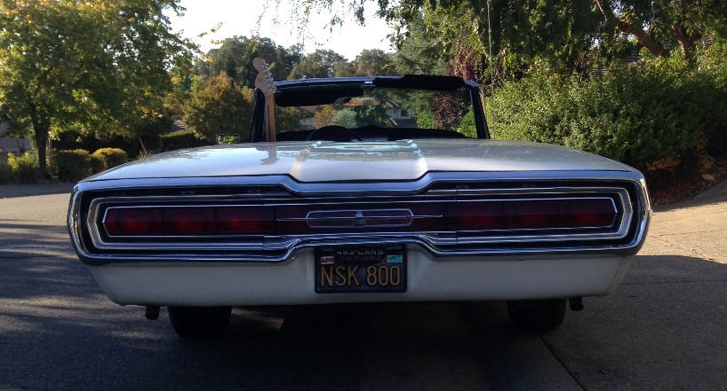

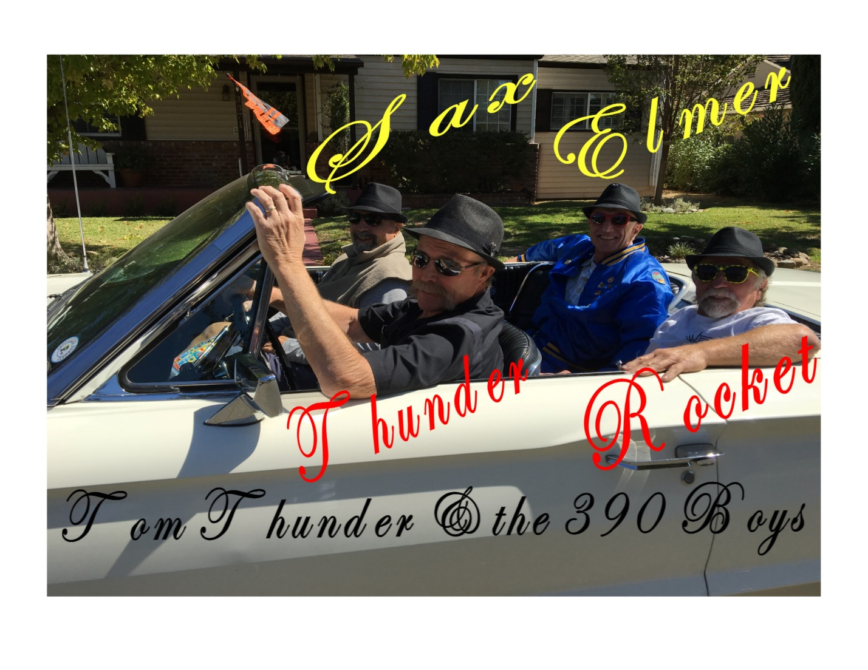
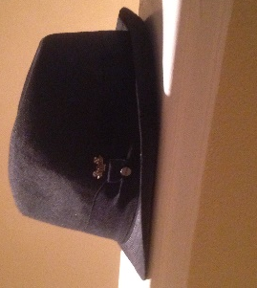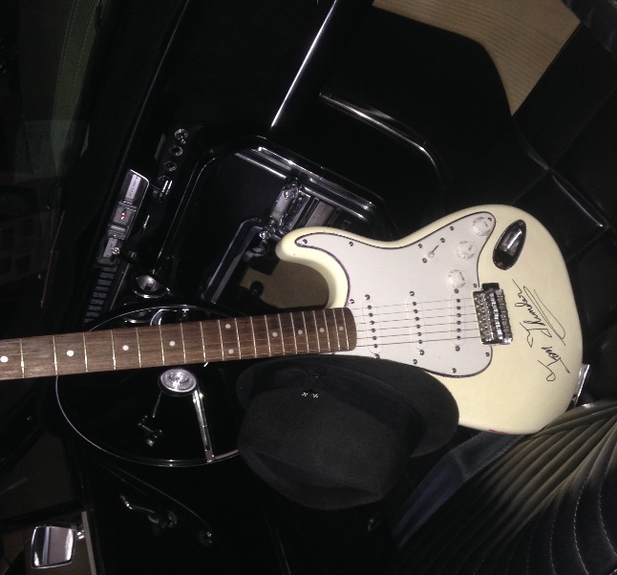
Rat Pack Hat Thunders AX

LIGHTNING AT THE WHEEL BIRD WATCHING

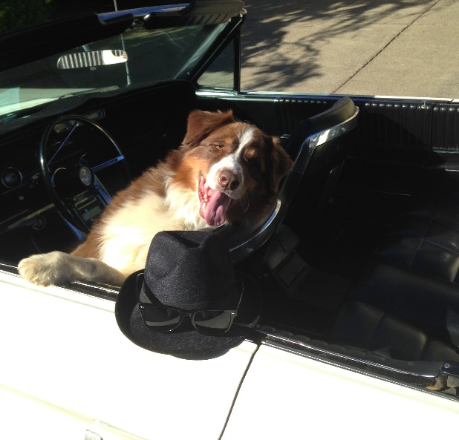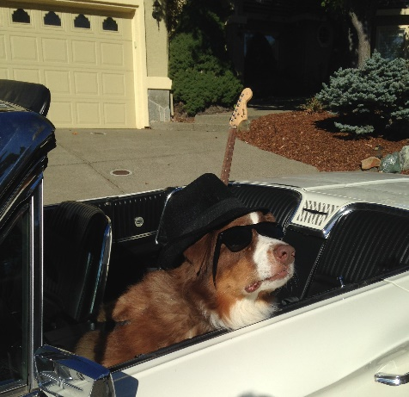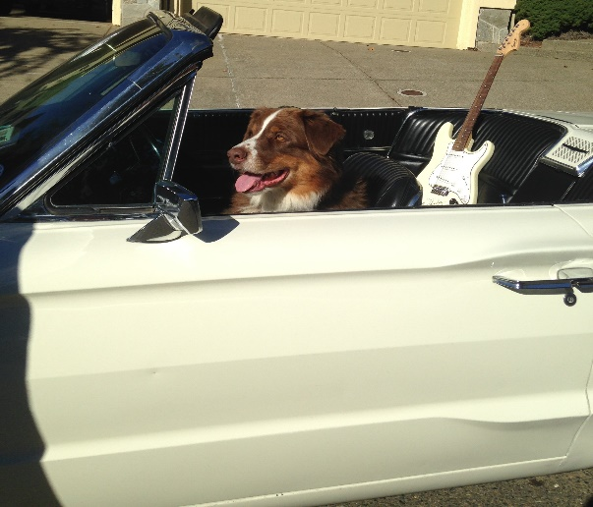
Thunders Ride
1966 THUNDERBIRD CONVERTIBLE
(CALIFORNIA GIRL)
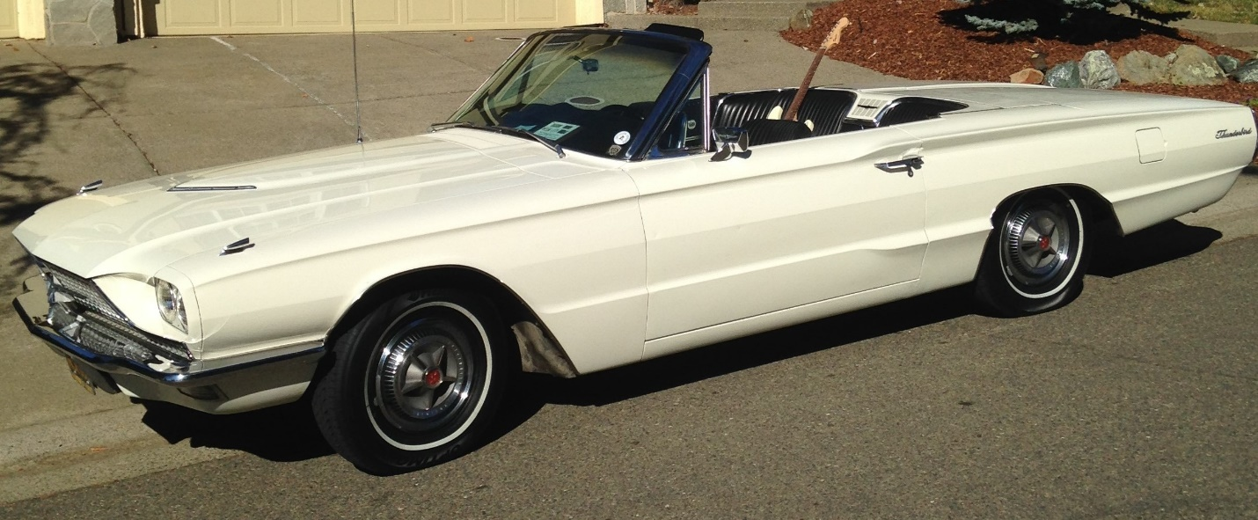

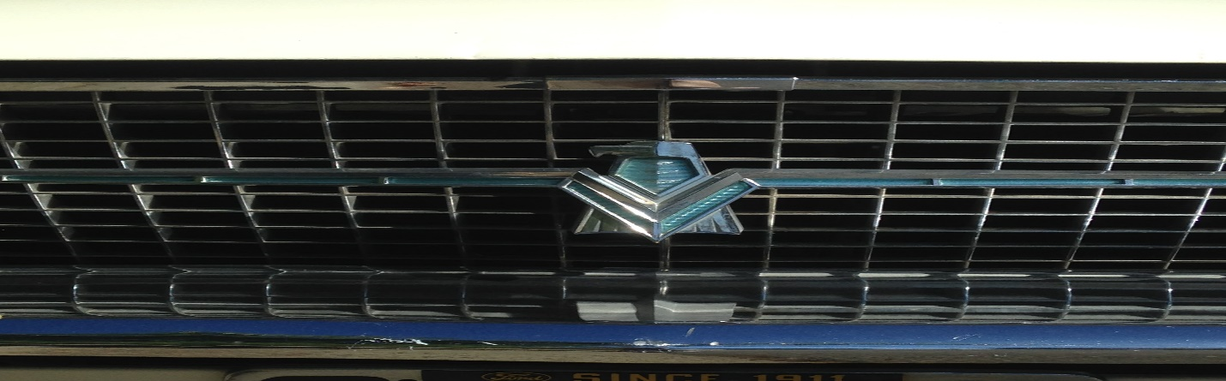

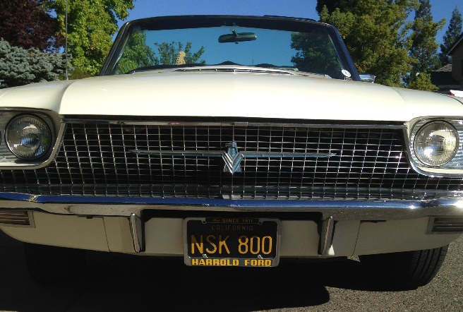

Thunder & Lightning - Ready For Another Adventure

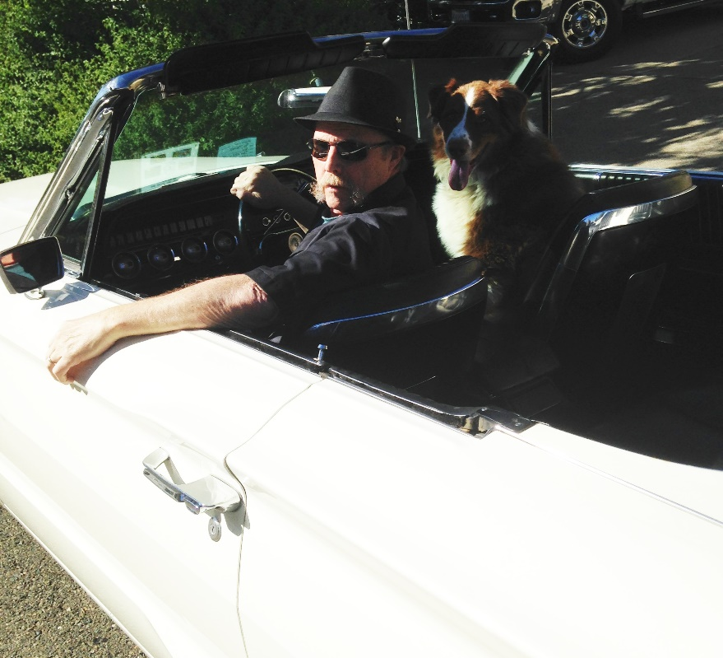

“Hit The Tune Box Buddy”

